CHAPTER ONE

INTRODUCTION

Background to the study
The ever changing trend in technology brought the necessity for the automation of everything from Paper-and-pen based to absolute computer domination. The overwhelming emergence of computers paved way to easier access to information that leads to increased production, efficiency and reliability.
The increasing urbanity of modern information system allows the information and communication technologies to be utilized in different actions. In fact, the educational institutions are one of the leading users of computer applications in order to manage student data.

Student Information Management System (SIMS) is a computer application that deals with the generation, collection, organization, storage , retrieval and dissemination of recorded knowledge.
SIMS provide capabilities for entering student information, building a student record and managing other student related data needs in school.

Definitions. Acronyms and Abbreviations
- Personal details: Details of student such as matric number. Phone number, address, image . email address e.t.c
- User ID: Student matric number
- Contact details: details of contact associated with the student
- SRS: System requirement specification
- DBMS: Database management system
- WWW: world wide web
- Admin: a login identity representing the user is an administrator and can access all the record details.
- Query : A request for information
- Database : A systematically arranged collection of computer data, structured so that it can be automatically retrieved or manipulated.
- Information: Definite knowledge acquired or supplied about something or somebody, also the meaningful material derived from computer data by organizing it and interpreting it in a specific way.
- System: a combination of related parts working together to achieve a particular goal.
- Management: the organizing and controlling of the affairs of a business or sector of business.
  - Technologies used:
- PHP
- MYSQL
- JAVASCRIPT
- HTML
- CSS

  - Overview
The rest of this SRS is organized as follows :
Section 2: gives an overall description of the software. It gives what level of proficiency is expected of the user and reports some general constraints while making the software.
Section 3 gives specific requirements which the software is expected to deliver. Some performance requirements and constraints are also given and deal with other Non-functional requirements
Section 4 deals with external interface requirements like hardware and software interface.

  - Problem Statement:
The regular day to day activities of every organized institutions and finance house involve recording searching, assessing and retrieval of data and information of student, client , patient staffs… e.t.c Design of Dynamic Student Information Management System can be used by education institutes to maintain the records of students easily. Achieving this objective is difficult using a manual system as the information may be very tine consuming. This project is embarked upon to design a versatile Student Information Management System to help in such situations.

Aim and Objectives
    - Aim: The aim of this project is to design a dynamic student information management system which will be adaptable for online registration and result computations.
    - The main objectives:
- Design an Online registration platform for students
- Maintenance of students records
- Searching student records
- Result computation and printable outputs.

Scope:
Without a Student Information Management System , managing and maintaining the details of the student is a tedious job for any organization.
Student information system will store all the details of the student including their background information, educational qualifications, personal details, result and all the information related to them

Login module: Login module will help in authentication of user accounts who have valid login id
(matric no) and password can only login into their respective accounts.

Search module: suppose there are hundreds of students and from this we have to search a particular student, it would be tedious using the manual system, but using this module, we can easily search the student by specifying a search criteria. Thus this module helps the administrator search student easily.
Registration module and Account Management: This module will help students get registered from anywhere internet can be accessed . This simplifies the task on paper registration. Also after registration, users can change their passwords and update their own information.

User Management: This module will help the administrator in enabling / disabling a user account and updating user information as required .

Purpose of project is to maintain details of students such as storing information about:
- Student id (Matric no)
- Student Password
- Student Full name
- Student Date of Birth
- Student mailing address
- Gender
- Registration Date
- Student status
- Contact no
- Result
- City
- Image

CHAPTER 2

LITERATURE PREVIEW

2.1 The Internet
Since the existence of the Multimedia Super Corridor (MSC), the Nigerian government has strongly highlighted the importance of ICT among people and organizations in Nigeria. The Internet starts to bloom and become a popular and competitive advantage to many organizations. In this world of technology, the internet is a popular medium to access and share information. It is the easiest and fastest way to broadcast and retrieve information. The Internet also provides unlimited access to anyone, any place at any time.

2.2 Student Information Management System vs Website
Student information management systems (SIMS) and websites are definitely different in terms of their definition where SIMS is a gateway to access information; meanwhile, websites represent the basic delivery of online content. There is chemistry between SIMS and websites where SIMS build on the same technology used for web sites, but enhance the functionality and flexibility to cater for the demands of specific classes of user.

2.3.1 Websites
Websites depend on the fact that the user has a browser such as firefox and chrome or the internet explorer, but carry on most functionality on a server.
The browser speaks HTTP and will render HTML’s code sent to it. Several additions to the basic protocol allow for instance cookies to be used for persistent communication, digital certificates to be used for authentication and javascript to give some necessary client-side functionality.
Web sites typically provide access to a variety of permanently on-line data linked using HTML references. CGI , the Common Gateway Interface provides a mechanism to invoke a script or executable program running on a web server. User input can be provided from a form , radio button or active map. Use of server-side CGI, JSP or PHP languages can also enable dynamic pages of information. Plug-in technology helps to render pages in special ways such as to show PDF documents , display VRML or other images, show video or play audio tracks.

2.3.2 Student Information Management System (SIMS)
SIMS builds on the same technology used for Web sites, but enhances the functionality and flexibility to cater for the demands of specific classes of user. This implies that SIMS always has more than just information to offer, as many websites do.
From both perceptions SIMS can be concluded as a gateway to web access where users can locate the entire web content they commonly need which requires personalization, search, channels, links, and customization based on role and workflow.

2.4 Major Functions of student Information management system
Student information management system is used by education to maintain the records easily. Achieving this objective is difficult using a manual system as the information is scattered , can be redundant and collecting relevant information may be very time consuming. All these problems are solved using this project
2.4.1 Search and Navigation
This functionality forms the basis for most of the successful public web apps meaning that a successful SIMS should support its users in an efficient search for contents. The web app should automatically present its users with the information appropriate to the user’s role and allow the user to search for information that was not previously known to be relevant to the user’s role, but which may be available through the SIMS,

2.4.2 Personalization
Personalization should be based on user roles , as well as user preferences. Personalization of navigation should provide shortcuts to specific information, mostly known as bookmarks or favorites. The design of personalization is such as the initial appearance of the SIMS, which may be pre-personalized according to the user’s role.

2.4.3 Collaboration and Groupware
Knowledge management and groupware ensure that the required information is stored in the right place and the right mode.This means that the right persons are brought together with the right information.

2.5 Technology overview
The technology for implementing Design of Dynamic Student information System Management System is PHP/MYSQL, Apache is used as the HTTP server. The development was done in a ‘windows’ environment using bracket , sublime text editor.
PHP
PHP is a general-purpose scripting language that is especially suited to server side web development where PHP generally runs on a web server . PHP Code is embedded into the html source document. Any PHP code in a requested file is executed by the PHP runtime, usually to create dynamic web page content . it can also be used for command-line scripting and client-side GUI applications. PHP can be deployed on many web servers and operating systems, and can be used with many relational database management systems (RDBMS). It is available free and the PHP Group provides the complete source code for users to build, customize and extend for their own use.

MYSQL
Mysql is a relational database management system (RDBMS) that runs as a server providing multi-users access to a number of databases. Mysql is a popular choice of database for use in web applications and is an open source product. The process of setting up a MySQL database varies from host to host, however we will end up with a database name, a matric no and a password. Before using our database, we must create a table. A table is a section of the database for storing related information. In a table we will set up the different fields which we will use in that table. Creating a table in phpMYAdmin is simple: we just type the name, select the number of fields and click the ‘go’ button. We will then be taken to a setup screen where you must create the fields for the database. Another way of creating databases and tables in phpMyAdmin is by executing simple SQL statements. We have used this method in order to create our database and tables.
APACHE
The Apache HTTP server is web server software notable for playing a key role in the initial growth of the world wide web. In 2009 it became the first web server software to surpass the 100 million website milestone. Apache is developed and maintained by an open community of developers under the auspices of the apache software foundation. Since April 1996 Apache has been the most popular HTTP server software in use. As of November 2010 Apache has over 59.36% of all websites and over 66.56% of the first one million busiest websites.

WAMP
WAMP is a small and light Apache distribution containing the most common web development technologies in one single package. Its content, small size, and portability make it the ideal tool for students developing and testing applications in PHP and MySQL. WAMP is available as a free download in two specific packages. Full and Lite . The full package provides a wide array of development tools while the Lite contains necessary technologies that meet the Ontario Skills Competition standards. The light version is a small package containing Apache HTTP server , PHP , MySQL, PHPmyAdmin, Openssl and SQlite.

Obtaining and installing WAMP
As mentioned previously, WAMP is a free package available for download and use for various web development tasks. All WAMP packages and add-ons are distributed through the Apache friends website http://apachefriends.org . a zip file containing an archive of the installation files needed for WAMP would be available. On installation, a new directory WAMP would be created in the root directory of your installation disk. We’ll test if all has been installed correctly by navigating to the WAMP directory and starting the Apache HTTP server by clicking the apache_start.bat file.
Next we will test if the server is running correctly by opening an internet browser and typing http://localhost/ into the address bar.
Creating a database and inserting data
Now that we have run and tested Apache and PHP, the next step is running MySQL and creating a database which will hold information to be used by our website. In order to start MySQL, navigate to the wamp directory and run MySQL_start.bat batch file. The WAMP package contains an application called phpmysqladmin which allows developers to administer and maintain MySQL databases, we will be using phpMyAdmin to create a database and table, and enter test data. Before testing phpMyadmin, make sure that both Apache and MySQL are running by opening their respective batch files: apache_start.bat and MySQL_start.bat. Along with apache and MySQL running in the background , we type http://localhost/phpAdmin/ into our web browser . If successful will be a phpmyadmin startpage.
The first step with phpMyadmin running is creating a new database. We create a new database by directly executing sql statements as shown below. The successful execution of the sql query creates a database ‘student’ with two tables in it. The tables are admin_login and student_information. We also inserted values in the admin table. After creating the database and tables we are now ready to use it in our Student Information Management System.

2.6 Users Views:
- Administrator
- Student

2.7 Platform
2.7.1 Operating System: Microsoft windows
2.7.2 Technologies used
- Front End: HTML, CSS and JAvascript
- Web Designing language : PHP
- Database management system (Back end): MySQL

2.7.3 Software Requirement
- PHP 5.0
- APACHE HTTP Server
- Bracket, Frontpage for Front End Programming
- Microsoft windows or Linux
2.7.4 Hardware requirements:
- Intel Pentium IV processor or equivalent or higher
- 512 MB Ram or Higher
- 20 GB HDD or higher
- Network Connectivity

2.8 Use Case Model
i. Administrator: Responsible for managing student records
Login into the website
Update student details
Search student details
Enable/disable student
Post student result
Print the desired pages
ii Student: Has the access rights to view and edit their personal details
Login into the website
Display student details
Edit their Details
Upload their Images
View/ Download /print their result

2.9 Assumptions and Dependencies
Administrator is created in the system already. Admin password and username are predetermined for security reasons.
Roles and tasks are also predefined

2.10 Specific requirements:
Use Case Reports
2.10.1 Administrator : Responsible for managing student details
i. Use-Case: Login into the website
ii. Goal in context: Gain access to the website
iii. Brief description : This use case is used when the administrator wants to access the website to enable / disable / update the personal details of the students
iv. Precondition : the administrator must be logged onto the website in order for this use case to begin.

Basic Flow:
- The Website prompts the administrator for the matric no and password
- The administrator enters the matric no and password.
- The website verifies the password and sets the user’s authorization.
- The Administrator is given access to the website to perform his tasks.

Alternative flow
The administrator enters invalid matric no and password then he will not be allowed to enter the website.
Post Conditions: The website state is unchanged by this use case.
Use Case Report: Login into the website
Use Case: Display student details
Goal in context: View the details of the student
Brief description: This use case is used when the administrator wants to view the personal details of the students already existing in the database on the screen.
Preconditions:
- The Administrator must be logged into the system in order for this use case to begin
- The details of the student must pre-exist in the database
- The student id must be entered correctly.
Basic Flow:
- The administrator logs on to the system
- The administrator search the student from the following keys
- Student id
- First / last name
- Registration date
- Status
- The system prompts for the student detail from one of the above keys
- The student details are displayed on the screen.

Alternative flow:
Student not found
If in the display , a student id ( matriculation no) doesn't exist , the system displays an error message. The administrator can then enter a different id number or cancel the operation , at which point the use case ends.
Post conditions :
The student details are displayed on the screen already existing in the system. The state of the system remains unchanged.

Use case: Edit student details
Goal in Context: Edit the details of a student
Brief Description: This use case is used when the administrator wants to edit the personal details of himself already existing in the database.
Preconditions:
- The administrator must be logged into the system in order for this use case to begin.
- The details of the student must pre-exist in the database.
Basic flow:
- The administrator logs on to the system
- The administrator can edit the following:
- First/ last name
- Gender
- Date of birth
- Contact number
- Qualification
- City
- Email
- Email2
- Address
- Description
- The website updates the database according to edited details
- The student details are edited in the database.

Alternative Flow:
There is no alternative flow of this use case diagram
Post Conditions:
The student details get updated in the database.
Use case report - Edit student detail into website
2.10.2 Student
Use : Student registration
Goal in context : registration of student
Brief Description : This use case is used when the student register himself/ herself in the database online.
Preconditions:
- The student must access the website for this use case to begin
- The user id must be unique and be entered correctly.
Basic Flow
- The student enters the website
- The student fills in the following keys:
- Student id
- Password
- Full name
- Status
- Gender
- Date of Birth
- Contact no
- City
- Email
- Address
- Image
- The System details
- The student details are displayed on the screen.
Alternative flow:
User ID not unique: If the user id entered if not unique then it is shows an error message.
Use case report- Registration student on website
Use-case: Login into the website
Goal in context : Gain Access to website
Brief Description: This use case is used when the student wants to access the website
Basic flow:
- The website prompts the student for the matric no and password.
- The student enters the matric no and password
- The website verifies the password and sets the user’s authorization
- The student is given access to the website to perform his tasks.

Alternative Flow
The student enters invalid matric no and password then he will not be allowed to enter the website.
Post conditions: the website state is unchanged by this use case.

Use Case Report - Login into the system.
Use Case: Edit student details.
Goal in context: Edit the details of a student.
Brief Description : This use case is used when the student wants to edit the personal details of him/herself existing in the database.
Preconditions:
- The student must be logged into the system in order for this use case to begin
- The details of the student must pre-exist in the Database.

Basic Flow:
- The Student logs onto the system
- The student edits the following keys
- Full name
- Gender
- Date of Birth
- Contact no
- City
- Email
- Address
- The website updates the database according to edited details
- The student details are edited in the database

Alternative flow:
There is no alternative flow to this use case.
Post conditions:
The student details gets updated in the database.
Use Case Report- Edit students details in the database.

Functional requirements:
- The Administrator will be given more powers to enable, disable and update than other users.
- It will be ensured that the information entered is of the correct format. For example the name cannot contain numbers. In case if the incorrect form of information is added, the user will be asked to fill it in again.
- The system can be accessed at any time.
2.12 Performance Requirement:
The proposed system to be developed will be used as the Chief performance system for providing help to the organization in managing the whole database of the student studying in the organization.
Therefore, it is expected that the database would perform functionally all the requirements that are specified.

2.12.1 Safety Requirements:
The Database may get crashed at any certain time due to virus or operating system failure. Therefore , it is required to take the database backup.

2.10.3 Security Requirements:
We are going to develop a secured database. There are different categories of users namely Administrator , student who will be viewing either all or some specific information from the database.
Depending upon the category of user the access rights are decided. It means if the user is an administrator then he can be able to modify the data, append e.t.c All other users only have the rights to retrieve the information about database.

CHAPTER THREE

RESEARCH METHODOLOGY

Design Phase
3.1 Overall System Design
The overall system Design objective is to provide an efficient, modular design that will reduce the system’s complexity, facilitate change and result in an easy implementation. This will be accomplished by designing a strong cohesion system with minimal coupling. In addition, this document will provide interface design models that are consistent user friendly and will provide a straightforward transition through the various system functions.

3.2 Structure of Design Document
- System Architecture Design - The System architecture section has a detailed diagram of the system, server and client architecture.
- Data Design - The Data Design includes Database Design .
- Functional Design Description - This section has the functional partitioning from the Student Result System (SRS). and goes into great detail to describe each function.

3.3 System Architecture Design
Change password
Edit profile
Register session
Check Student Result
Print result
Create class
Create subject
Manage Class
Manage subject
Create result
Manage student information
Logout

Admin Login
Student Login
Logging checker
Logging checker
Database

Admin Home
Student HOme
Change Password
Edit Profile
Register Session
Check result
Print Result
Log out

3.4 System Architecture
The Design of Dynamic Student Information Management System is a system which contains major parts which includes: Student Detail , Student Image and Resume. The user selects one of the available options as an input to the system.

According to the input by the user the system acts and the rest of the functions are performed accordingly. The administrator can operate on any student details. But the normal student or users can only access their details of all the functionalities.

3.5 Conclusion
Hence we can conclude that the design phase of the Student Management System SIMS give us the information of all the processes used in the project and their relation.

3.6 Project Description
Design of Dynamic Student Management System can be used by education institutes to maintain the records of students , easily and efficiently. Achieving this objective is difficult using a manual system as the information is scattered, can be redundant and collecting relevant information may be very time consuming. All these problems are solved using this project. The directory structure of the project is as follows.

3.7 Description of root directory contents \
- User_Images Directory: This directory contains the images uploaded by the students during registration process. Supported formats are the .jpg and .gif files
- JS DirectoryL: This Directory contains all javascript
- Include Directory: This Directory contains all the configuration files.
- Fonts Directory: This Directory contains all the font use for the development of the project.
- Database Directory: This Directory contains the database backup.
- CSS Directory: This Directory contains all the CSS file
- Activepassword.php: Page for password connectivity. It is used whenever password values are required to access a page.
- Activepasswordck.php: Page for Password connectivity check. It is used whenever Activepassword.php is passing values that are required to access a page.
- Change-password.php: Page for Password connectivity check. It is used whenever user want to change password values.
- Change-passwordck.php: Page responsible for password change check. It is used whenever user want to change their password.
- Edit_Student.php: Admin Page for editing information of a student.The administrator can change details for a student in this page. Though facility of changing the image and resume are not yet provided but will be provided in the future versions of the project.
- Admin_Header.php: Header file for pages accessible to administrator alone
- Admin_Home.php : Homepage for administrator after logging in.
- Admin_login.php: Login page for administrator access. Shows appropriate message for wrong matric no and or password.
- Admin_Login_Handler.php : Page handler for Admin_Login.php page. It checks the values provided with the values in the database.
- Config.php : Page for database connectivity. It is used whenever database values are required on the page.
- Manage_student.php: page to display all registered student to the administrator. This facility is only available to the administrator.
- Leftbar.php :left file for all pages.
- Topbar.php : top file for login page and homepage of the site
- Index.php : Homepage of the website
- Logout.php : Logout handler page. Terminates all user session
- Search.php : Search page to search for students. Only accessible to the admin. Students can be searched using different fields such as account status and user id e.t.c
- Search_result.php: Page to display search results to the administrator.
- Search_view_Result.php: Page to display student information for any selected search result.
- Student_Edit.php : Page to edit student information. It can be accessed by students.
- Student_Edit_Handler.php : Page Handler for Student.php
- Student_Header.php : Header file for students pages
- Student_Home.php : Header file for students after they log in to their accounts.
- Student_login.php : Login page for student login, appropriate message displayed if login unsuccessful.
- Student_login_handler.php : Page handler for student_Login.php. In check the values provided with that in the database.
- Student_Registration.php : Student Registration page. The student enters various details here for registration.
- Student_Registration_handle:Page Handler for handling the file Student.registration.php. It adds value to the student information table thus creating a new user.
- Student_Reset_Password.php : Page for resetting password. It can be used only by students. Administrator password can be changed only by changing the values in the table directly.
- Reset_Password_Handler.php : Page handler for handling page.
- Student_View.php : Page to display student profile with all the details of the student.
- Style.css : Stylesheet for the whole site Design
- Validation.js : Javascript validations used for validation of form values. Various form entries are validated at the client.

3.9 Description of Database Tables
3.9.1 admin_login :
- User_id : stores user id of administrator(s).
- Password : Stores password of the administrator(s).
- Last_login_date : Stores the last login date of the administrator(s).
3.9.2 Student_information :
- Student_id : stores user id of the student(s)
- Student_password : stores first name of the students
- First_name : stores first name of the student(s)
- Last_name : Stores last names of the students.
- Registration_date : stores the registration date of the students
- Gender : stores the gender of the students
- Date_of_birth : stores the date of the birth of the students.
- Student_status : stores the current status of the student accordingly
- Contact_no : stores the contact number of the student.
- Qualification : stores students qualification.
- City : stores the city in which the student lives.
- Email1 : stores primary email of the students
- E-mail2 : stores the address of the students
- Address : stores description of the students
- Image : stores description of the students
- Image : stores image of the student.
- last_login_date : stores the last login date of the students.

Features
The website provides following functionalities to the users :
3.10.1 Administrator :
- Login/logout
- View student Information
- Edit student information
- Enable/disable student information
- Search students

3.10.2
- Login/logout
- View profile
- Edit profile
- Change password
- Register new profile

CHAPTER FOUR

RESULT AND DISCUSSION
4.1 Results
In this section, snapshots of various inputs and output interfaces and the system functions are presented with description.
This is the homepage/ index page of the site also the student login page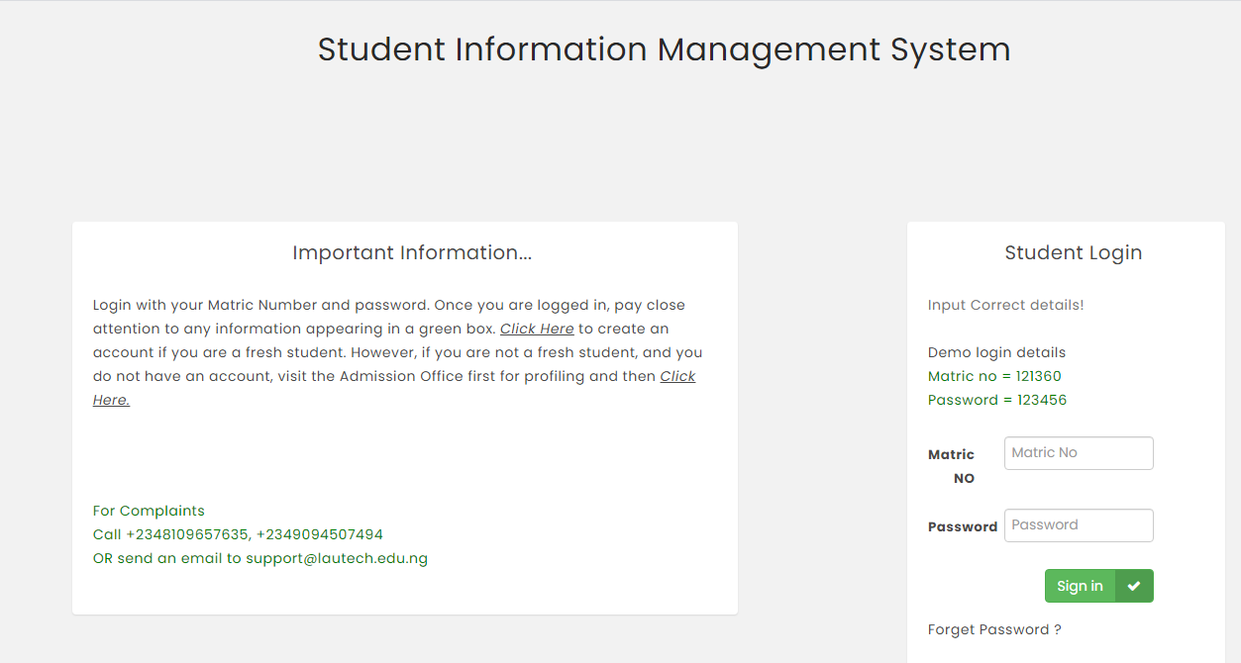
This is the registration page 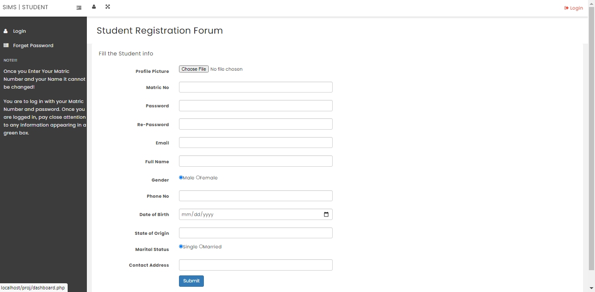

After successful registration the students can then login into their accounts with the matric no and password they chose during registration.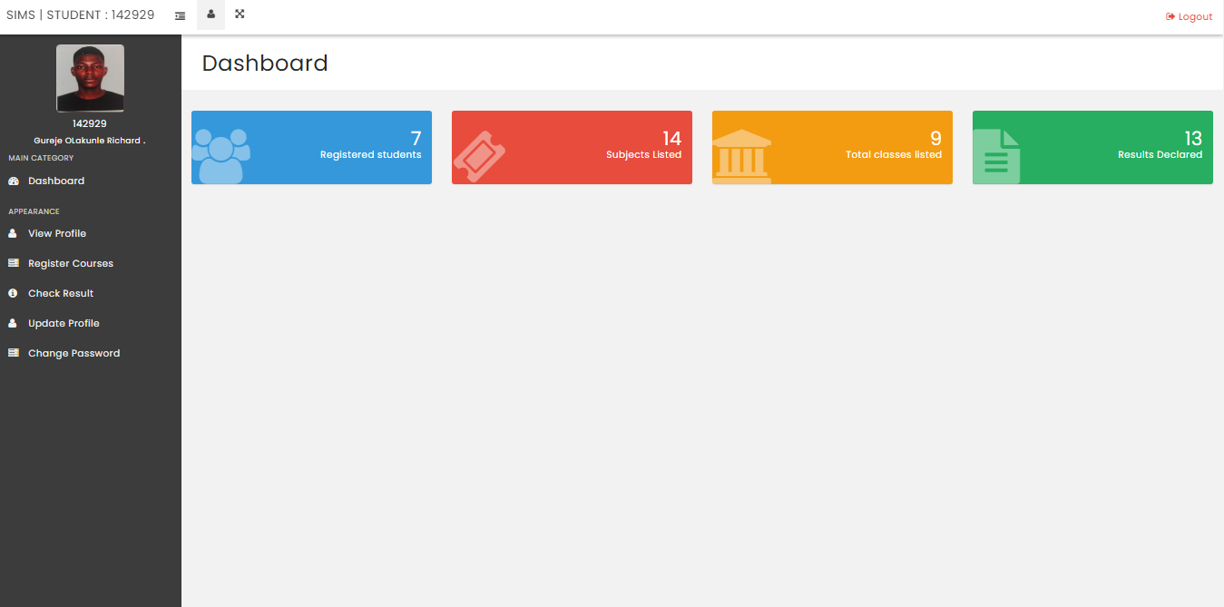
After logging in . the homepage above is shown.
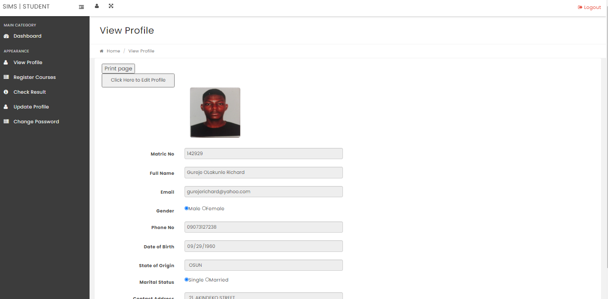
The student can view their profile. The above page shows the user profile.

The students can also edit and update their profiles as shown below.
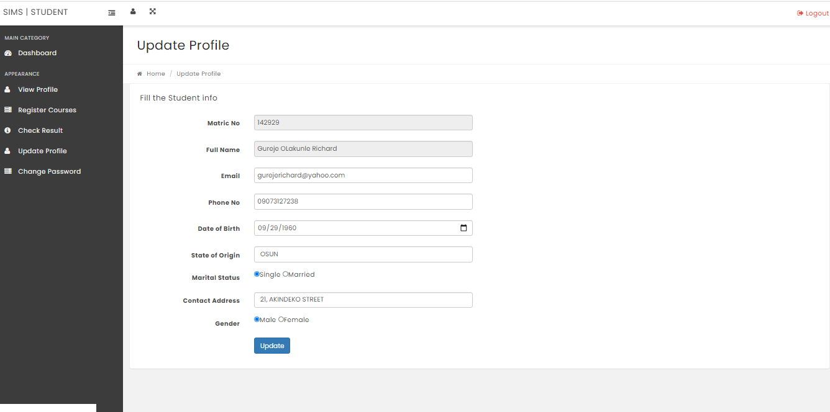

Change password as shown below
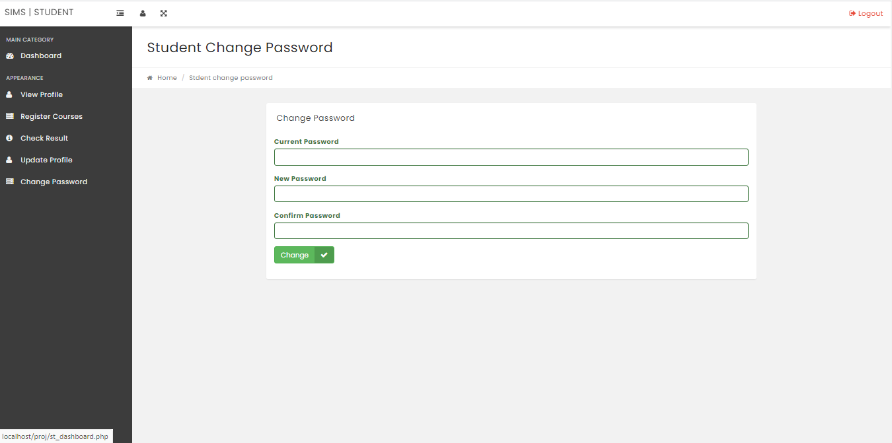

Below is a way to check for results
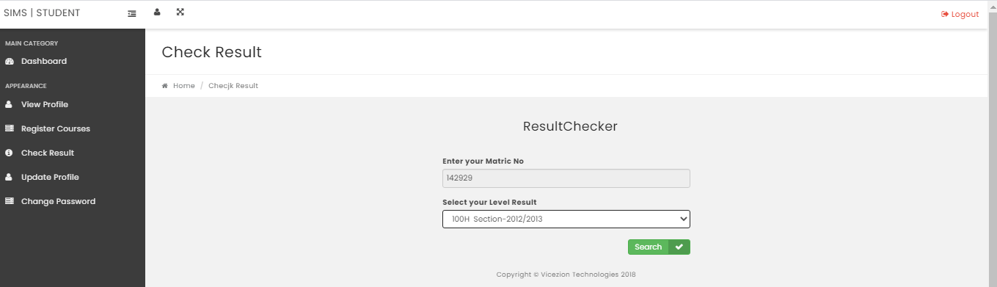

Below is the students result for a semester
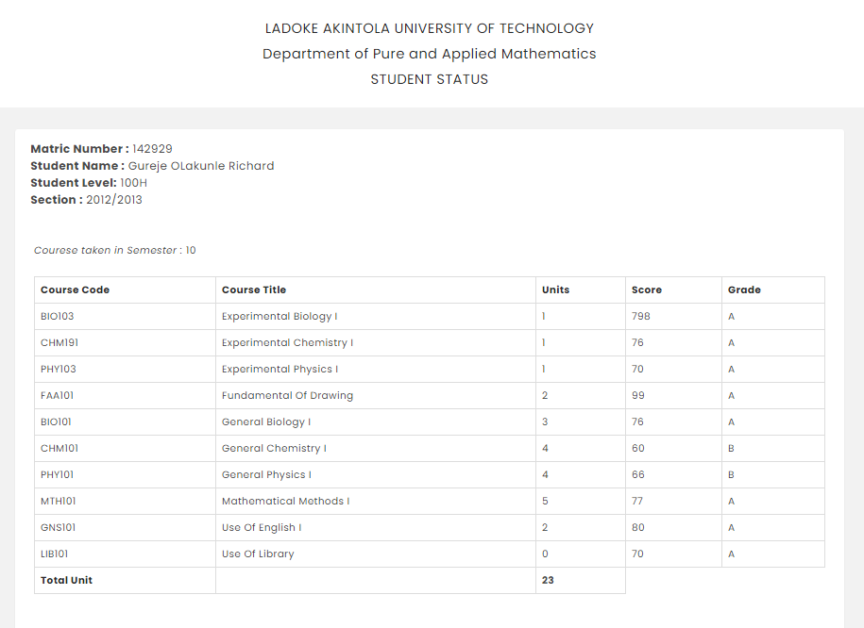

The Page below shows a full print of the result
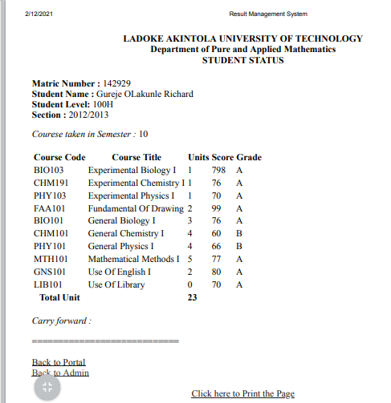

Adminstrator Login Page
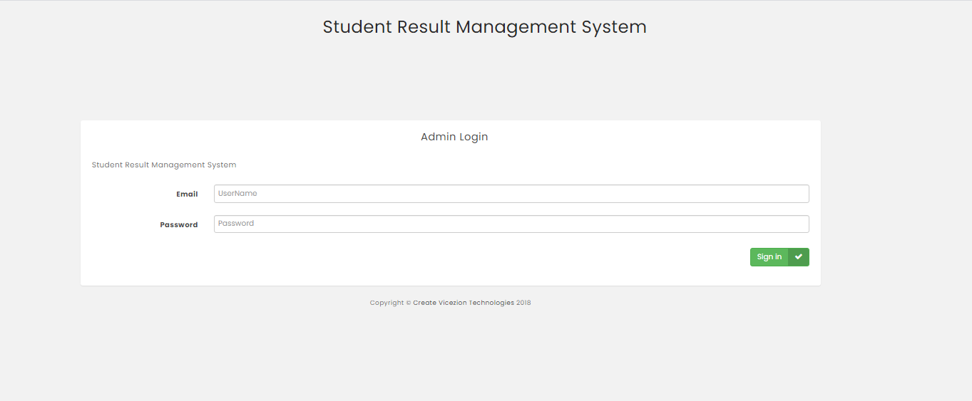

Next is the admin home page as shown below
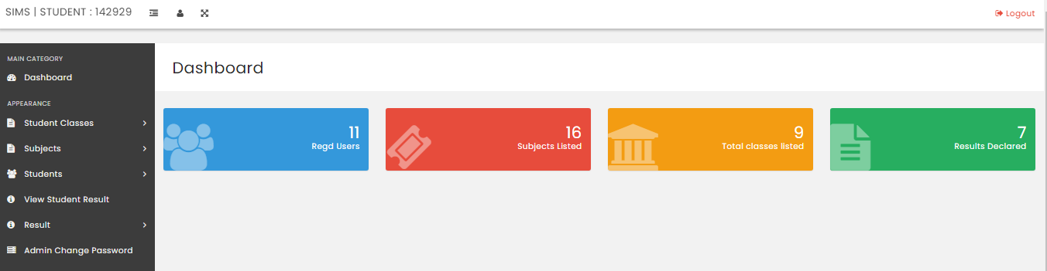
The administrator can manage the students through this page
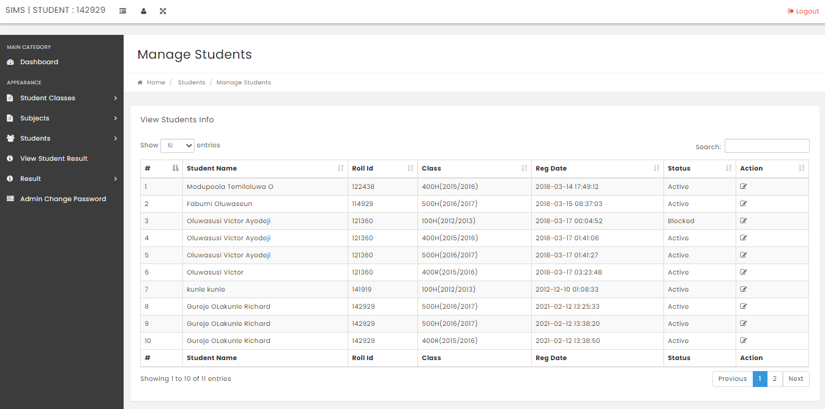

This is the search result page for managing the students
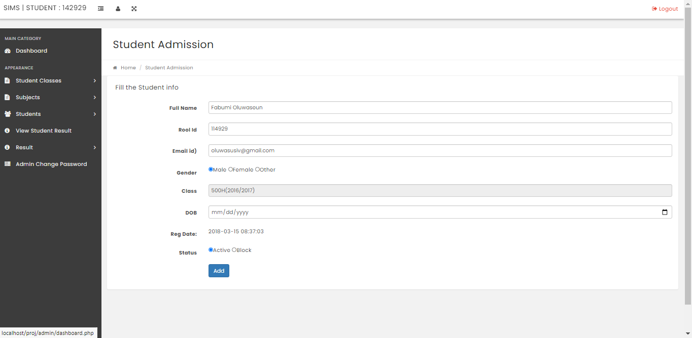
When there are no results. An appropriate message is displayed. 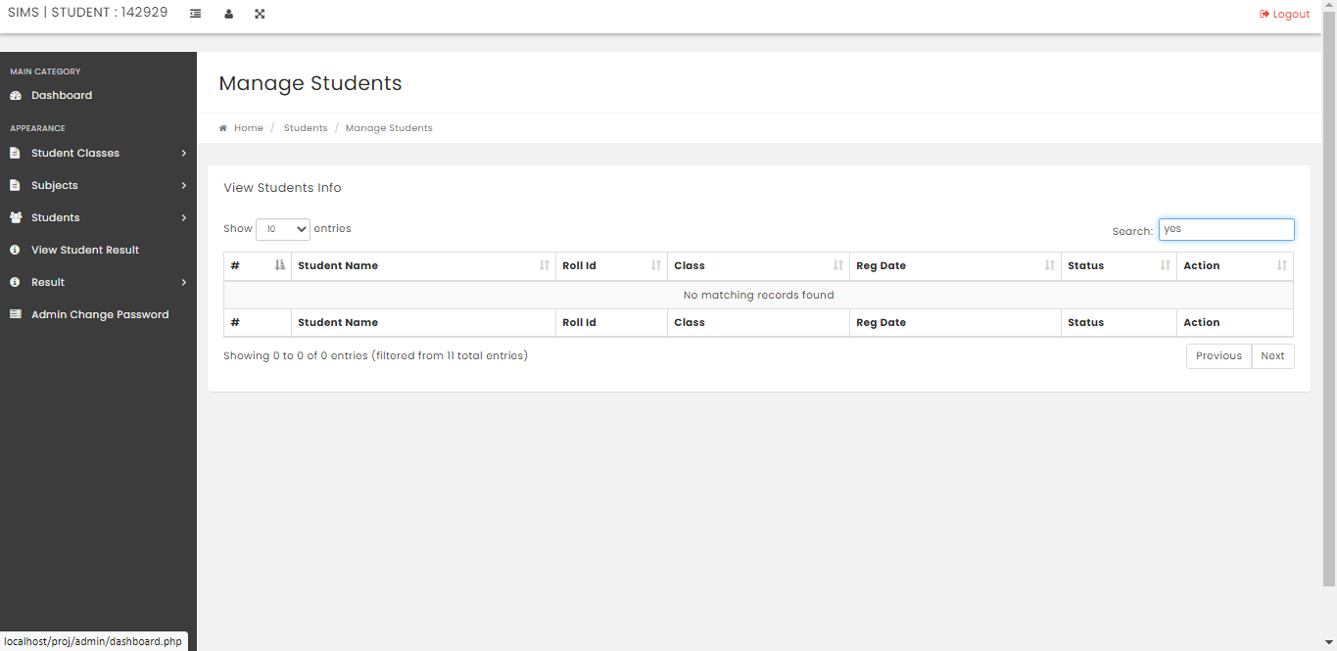

The admin also has the permissions to check the results of student he edits too.


4.2 Flexibility and Adaptation
- The design of dynamic student information system can be enhanced to include some other functionality like marks , attendance management.
- Talent management of students based on their performance evaluation can be added .
- Social networking can also be added wherein students can interact with each other.\
- Online class functionality can be added.
- Can evolve as an online institution
- Functionality of chat and video messages can be added
- Online exam functionality can be added
- Online resume builder functionality can also be added

4.3 Conclusion
Very versatile information management system for proper handling of institutions information is developed . The design of dynamic student information management system will lead to a better organization structure since the information management of the students is well structured and also lead to better as well as efficient utilization of resources. This system can be used by education institutes to maintain the records of students easily.
All problems solved using this project,was developed by Gureje Olakunle Richard using a step by step approach with organizational knowledge gained during an industrial training period at BOVAS AND COMPANY helping in developing the project “Design of a Dynamic Student information Management System”

